**PLC**

A programmable logic controller (PLC) Is an integrated digital computer that has been roughened and adjusted for manufacturing process control, such as assembly lines or autonomous systems, or any operation requiring strong quality command and convenience of programming and system failure diagnosis.

The goal of this lab is to get a similar experience as hands on for Logic Design. This lab will make us think of how like a computer. At the end of this lab we will demonstrate our understanding by created an application that is used in the real world with the same logic

**Procedure**

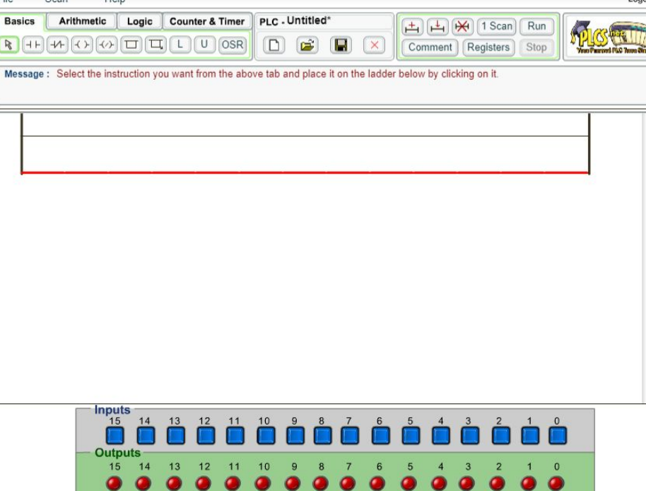

We are going to use online PLC simulator to created:

* Logical And
* Logical Or
* Logical NAND
* Logical NOR

**AND Gate**

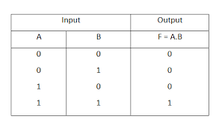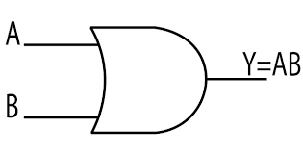 An AND gate is a digital logic gate with two or more inputs and one output that performs logical conjunction. The output of an AND gate is true only when all of the inputs are true. If one or more of an AND gate's inputs are false, then the output of the AND gate is false.

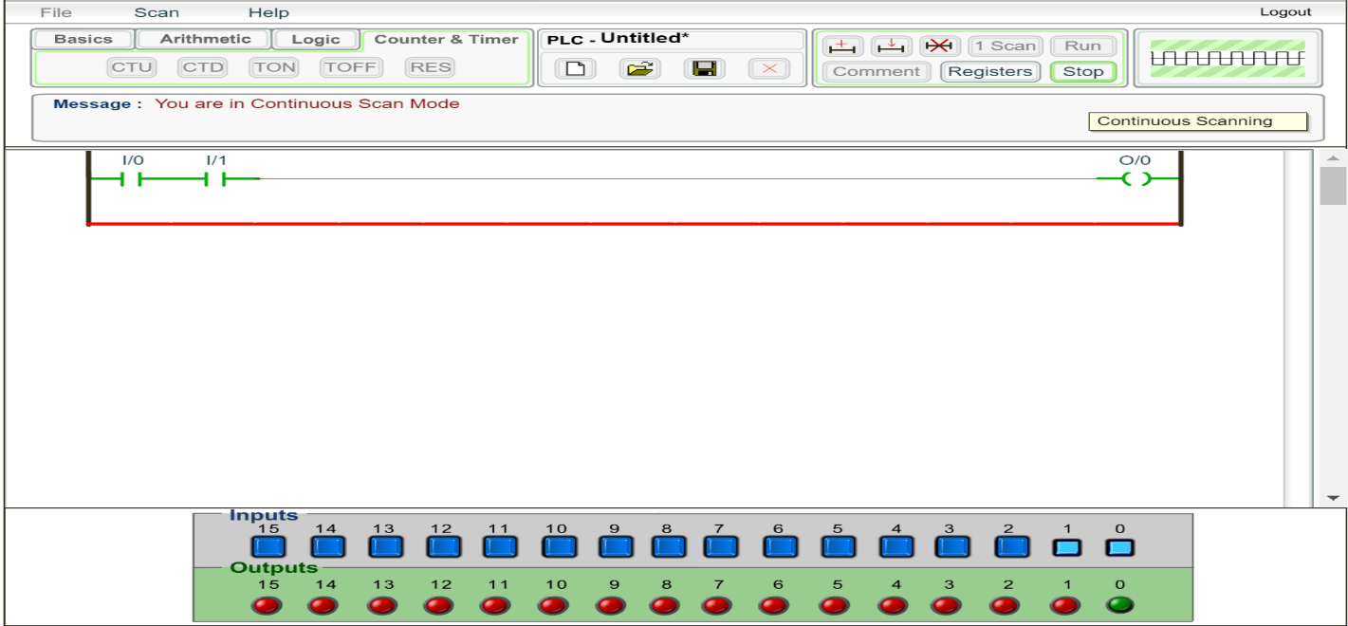

**OR Gate**

An OR gate is a digital logic gate with two or more inputs and one output that performs logical disjunction. The output of an OR gate is true when one or more of its inputs are true. If all of an OR gate's inputs are false, then the output of the OR gate is false.

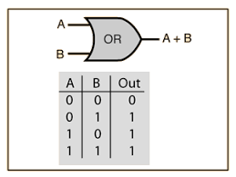

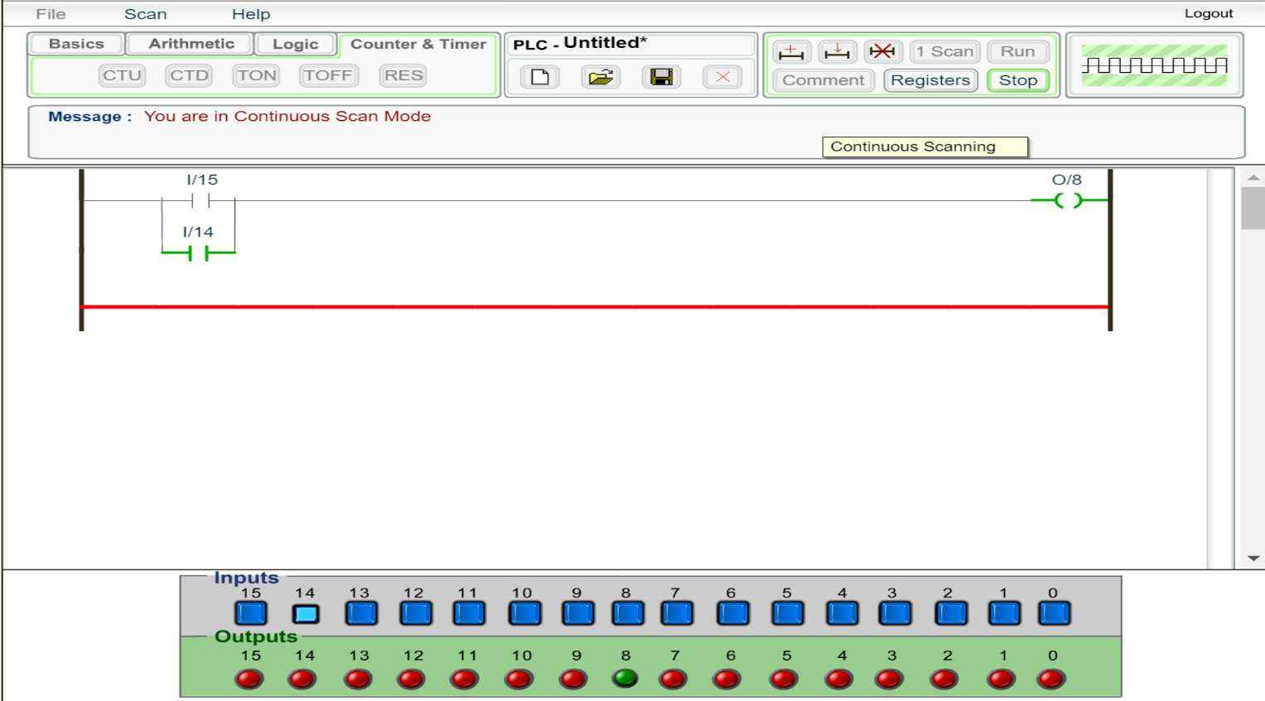

**NAND Gate**

a **NAND gate** (NOT-AND) is a logic **gate** which produces an output which is false only if all its inputs are true; thus its output is complement to that of an AND **gate**.

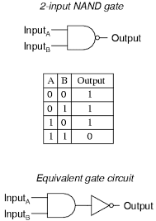

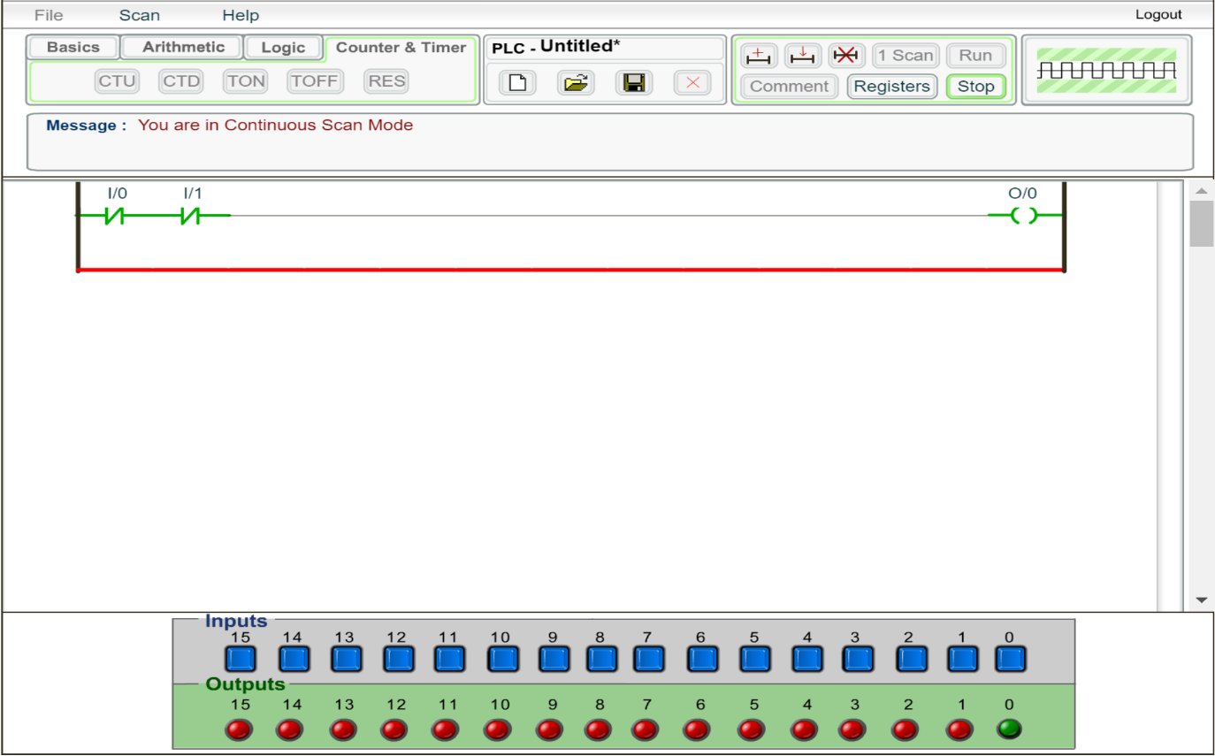

**NOR Gate**

NOR gate is a digital logic gate that implements logical NOR - it behaves according to the truth table to the right. A HIGH output (1) results if both the inputs to the gate are LOW (0); if one or both input is HIGH (1), a LOW output (0) results. NOR is the result of the negation of the OR operator.

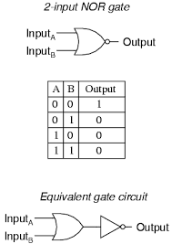

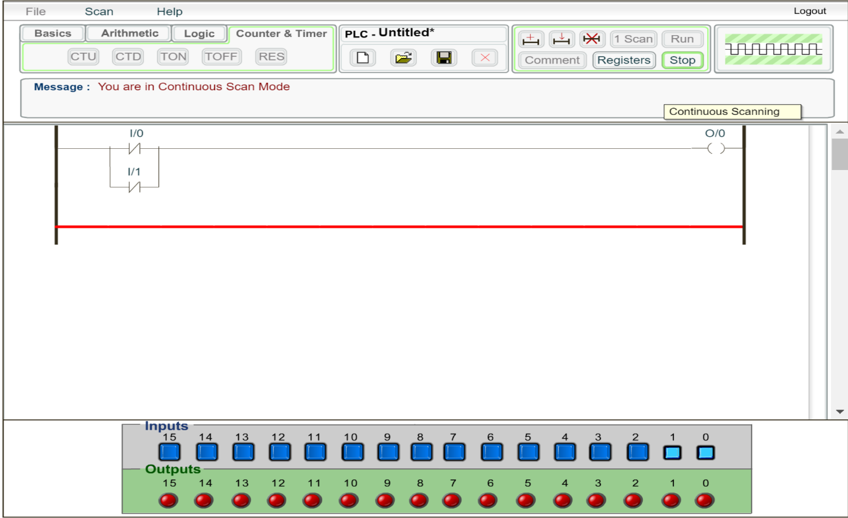

**Industrial application**

In this part we are going to build Alarm System using PLC. The idea of the logic is to set up the alarm in case of Door, Window, or camera deduct something.

The system will have three LED which is LED1, LED2, LED3

LED1 (OR) : will have 4 doors. If any of the doors are opened the input will be 1, therefore the output of that digital logic would be 1 and leads to ALARM.

LED2 (AND) : will have 2 cameras. If both cameras deduct motion with in its perimeter, it will push 1 into the gate which leads to ALARM.

LED3 (OR) : will have 5 Windows. If any of the windows are opened the input will be 1, therefore the output of that digital logic would be 1 and leads to ALARM.

Picture 1 : Shows a door is open.

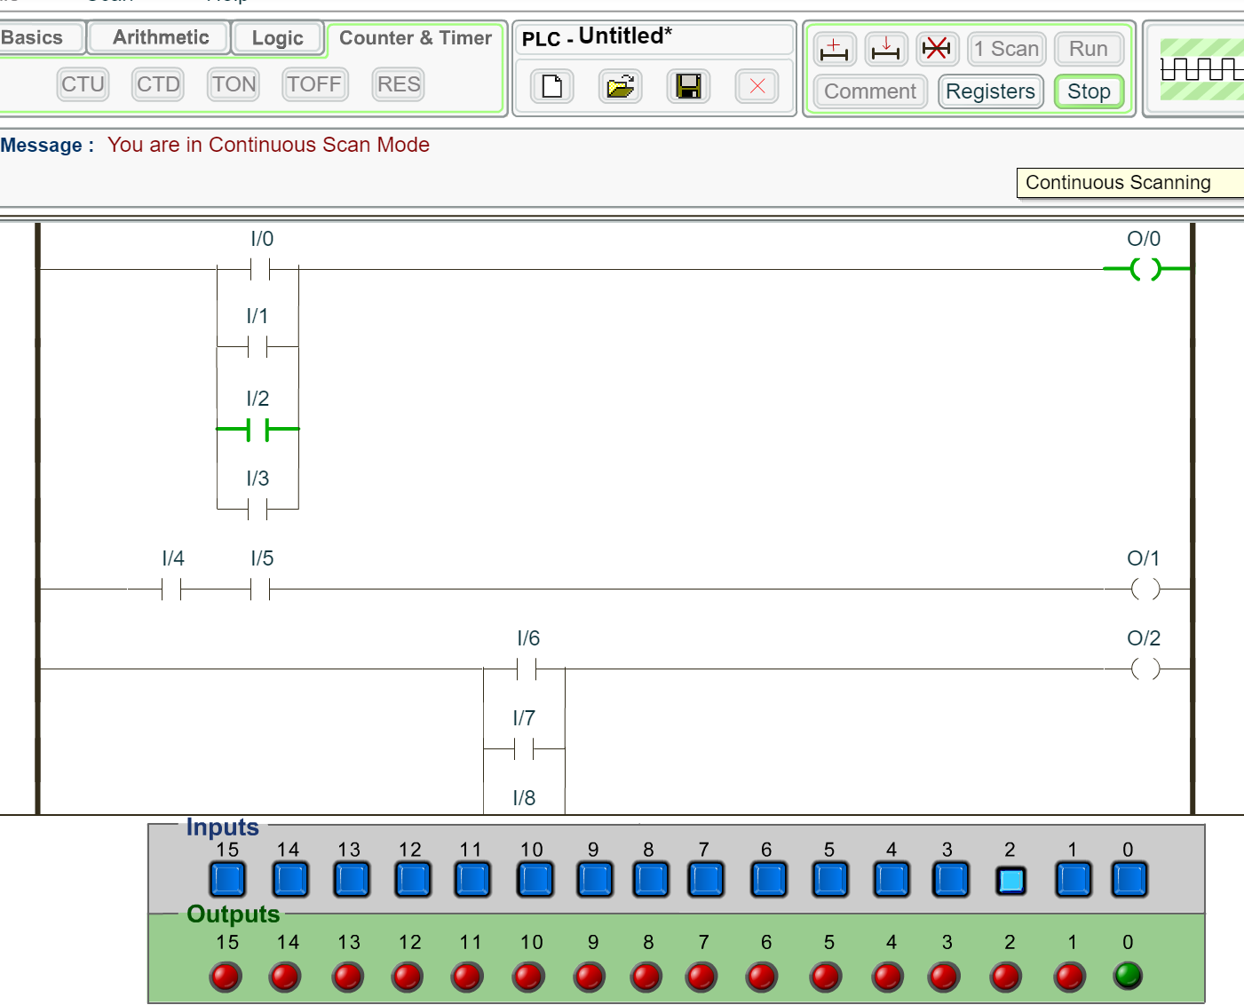

Picture 2 : Shows both windows sensing motion

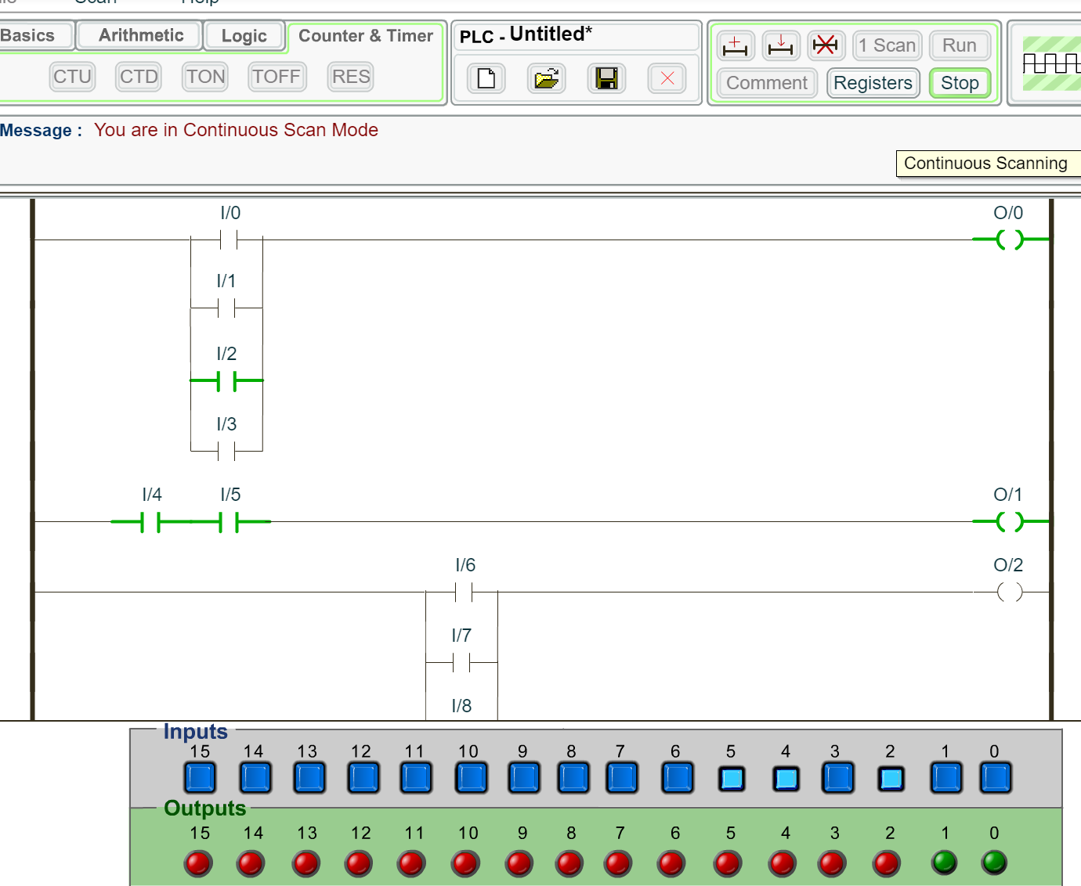

Picture 3 : Shows 3 windows are open

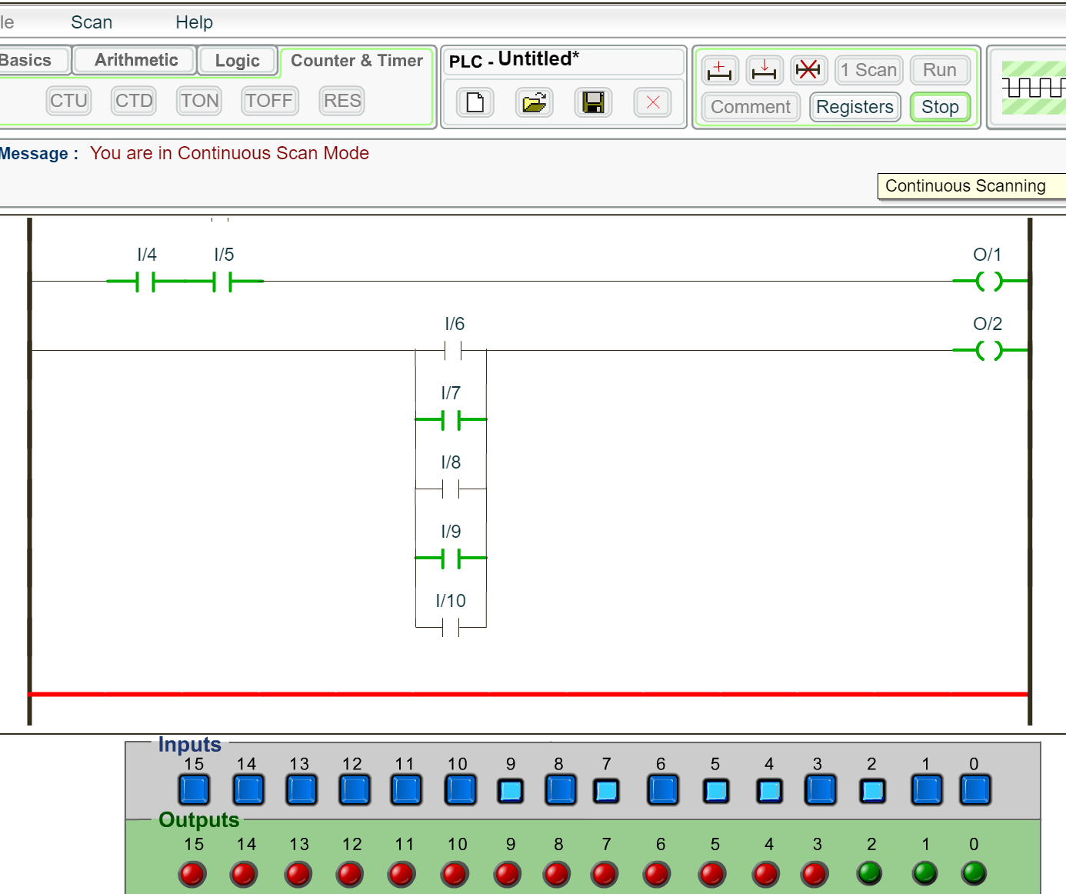

**Conclusion**

Ladder logic is very important concept in computers. It drives the structure of computers and how the physical components process the information. It was fun lab and we finally got to think and design an application that uses what we learned in Logic Design Classes.